Local SLM Research Paper Assistant — Architecture & Implementation Plan
Oct 31, 2026 · @Someone

Executive summary
Build a local-first, framework-free agent: a typed Python state machine over one embedded database, with structure-aware (Proxy-Pointer) retrieval so a 7–9B model only ever sees whole, relevant paper sections inside a fixed token budget.
Layer | Choice | Why this, not the alternative
Inference | Ollama for dev, llama.cpp server for tuned prod; both behind one OpenAI-compatible client | Swap runtimes without code changes; Ollama gives JSON-schema constrained decoding out of the box
Generator model | 7–9B instruct model with native tool calling, Q4_K_M (Q5_K_M if VRAM allows) | Best quality per GB on consumer GPUs; Q4_K_M is the usual knee of the quality/size curve
Router model | Same model at temperature 0 with a tiny enum schema (optional 1.5–3B model later) | Routing is classification; constrained enums make even small models reliable
Embeddings | Local embedding model via Ollama (e.g. nomic-embed-text or bge-m3) | No network dependency; good retrieval quality at low cost
PDF parsing | Docling as primary, PyMuPDF4LLM as fast fallback, GROBID optional for bibliographic metadata | Docling keeps headings, tables and figures as structure; GROBID is purpose-built for scholarly metadata and references
Retrieval | Proxy-Pointer: embed small breadcrumbed pointers, load whole sections | Precise hits without feeding fragmented chunks to a small model
Storage | One SQLite file: relational tables + FTS5 (BM25) + sqlite-vec (vectors); Postgres + pgvector behind the same repository interface for multi-user | Agent state, memory, document tree and vectors stay transactionally consistent; no sync drift between stores
Orchestration | Native async state machine with Pydantic state, no LangChain | Every prompt and transition is visible, testable and checkpointable
Structured output | Pydantic models → JSON schema → Ollama format; Instructor for validate-and-retry | Grammar-level constraint plus a semantic validation loop
API | FastAPI + Server-Sent Events of typed run events | Simple one-way streaming, works through proxies, trivial to consume
Frontend | React + Vite + Tailwind, three panes (chat, research log, sources); Chainlit for a throwaway prototype | Decoupled from the backend; the event stream drives all three panes
A runnable backend skeleton accompanies this doc (section 9).

1. Architecture synthesis
Four ideas from the recent literature converge on one design: keep orchestration simple and native, treat context as a scarce budget, give the agent a curated knowledge base, and retrieve by document structure rather than by blind chunks.
Native agents over heavy frameworks. Anthropic's Building effective agents reports that the most successful teams used simple, composable patterns rather than complex frameworks, and advises starting with direct LLM API calls and adding agentic steps only when simpler designs fall short. It separates workflows (predefined code paths) from agents (the model directs its own tool use). For a local SLM this distinction matters more, not less: small models are weaker planners, so we keep a deterministic workflow skeleton and grant autonomy only inside bounded tool loops.
Context engineering. Anthropic's Effective context engineering for AI agents frames the goal as finding the smallest set of high-signal tokens that maximize the desired outcome, and recommends compaction, structured note-taking outside the window, and clean sub-contexts for long tasks. It also warns that if a human cannot say which tool fits a situation, the agent will not do better. With an 8k–16k window, these are not optimizations; they are the core design constraint. We implement them as an explicit context assembler with per-slot token budgets.
Agentic knowledge bases. The New Stack's survey of agentic knowledge base patterns finds teams building purpose-built knowledge layers, mostly from ordinary parts such as versioned markdown, YAML and catalog tables exposed through APIs, with context engineering as the leading use case. For us the knowledge base is the paper corpus plus the agent's own research notebook, exposed only through a few narrow tools.
Memory needs an operational store, not just vectors. Recent analyses argue that agent memory is mostly write-side work (fact extraction, deduplication, invalidation) that a vector index does not do, and that separate vector and operational stores drift out of sync (Hindsight, Towards AI). Hence one transactional database holding state, memory and vectors.
Proxy-Pointer RAG. The Towards Data Science series by its author (part 2, multimodal) builds a heading-derived skeleton tree, injects breadcrumbs (e.g. Methods > 3.2 Training) into small indexed pointers, and on a hit loads the complete section instead of the fragment. The multimodal follow-up handles figures and tables with a text-only index, chunking at section boundaries rather than by character count. Research papers are ideal for this: they are rigidly sectioned, and their figures and tables have captions.

2. Technical trade-offs
Each decision below trades some convenience for control, consistency or context efficiency, which are the three things a local SLM is shortest on.

Orchestration: native state machine vs framework
Option | Gains | Costs | Verdict
Native state machine (chosen) | Every prompt is a visible string; node-level unit tests; trivial checkpointing; no hidden prompt templates fighting your SLM-tuned ones | You write the loop, retries and tracing (~400 lines) | Default
LangGraph | Ready graph runtime, checkpointers, human-in-the-loop | Extra abstraction and dependency churn; still need custom SLM prompts | Adopt only if you need durable multi-day runs
LangChain agents / chains | Fast demos, many integrations | Opaque prompts tuned for frontier models; hard to constrain outputs per step | Avoid for the core loop
Router design: a constrained-enum router (one call, schema {route: "chat" | "search" | "deep_read" | "compare" | "ingest"}) beats a free-form ReAct planner on 7B models. It turns open-ended planning into classification, which small models do well, and each route maps to a short, mostly deterministic subgraph.

Agent memory: vector store vs operational database
Concern | Dedicated vector DB (Chroma, Qdrant) | Operational DB with vectors (SQLite + sqlite-vec, or Postgres + pgvector)
Consistency | Separate store; deletes and updates can drift from source of truth | Same transaction as the row; no drift
Query shape | Similarity only, plus metadata filters | SQL joins, recency, validity windows, FTS5 BM25, and vectors in one query
Run state and checkpoints | Needs a second store anyway | Same file
Scale ceiling | Millions to billions of vectors | Brute-force or IVF fine to roughly 10^5–10^6 vectors locally
Ops cost locally | Extra service | Zero (embedded file)
A personal research library is thousands of papers and well under a million vectors, so the operational database wins. Keep a VectorIndex interface so FAISS or Qdrant can slot in if a corpus outgrows it.

Retrieval: fixed chunks vs Proxy-Pointer
Aspect | Fixed-size chunk RAG | Proxy-Pointer (chosen)
What the model sees | Top-k fragments, often cut mid-argument | Whole sections (or subsections), with their path in the paper
Context use | k × chunk size, much of it redundant overlap | One to three sections, sized to fit the budget
Precision | Embedding noise from mixed-topic chunks | Small pointer vectors carry breadcrumb + summary, so hits are sharp
Figures and tables | Lost or garbled | Separate nodes; caption + breadcrumb indexed as text, content loaded on demand
Failure mode | Missing context → hallucination | Oversized section → must be split or summarized (handled by the budgeter)
Cost | Lowest ingestion cost | Small extra: tree build is pure Python; optional per-section summary is one SLM call per section
The key SLM benefit: retrieval precision comes from many small vectors, while the generator receives a few coherent, complete sections, so a 7B model reasons over intact arguments instead of stitching fragments.

3. System architecture
Seven components run in one Python process plus the model runtime; the frontend talks only to the API, and every piece of state (documents, vectors, run checkpoints, memory) lives in one SQLite file.
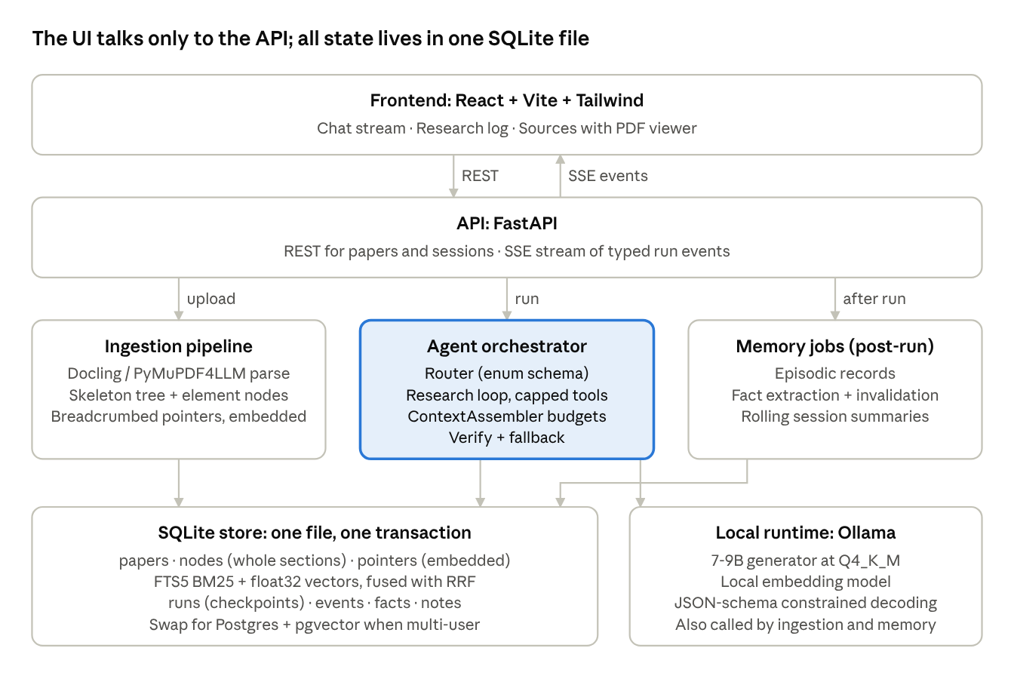
system architecture · 7 components
The orchestrator is the only component on the request path that loops; ingestion and memory jobs run in the background and share the same store and runtime.

Module layout
app/
config.py settings + per-slot token budgets
llm.py runtime client: constrained JSON, validate + re-ask, streaming, embeddings
db.py schema, hybrid search (BM25 + vectors, RRF), checkpoints, events, memory tables
ingest/
parser.py PDF -> Markdown (Docling, PyMuPDF4LLM fallback)
tree.py skeleton tree, element nodes, sizing, pointer text (pure Python)
pipeline.py fingerprint -> parse -> metadata -> tree -> embed -> atomic commit
agent/
state.py RunState + every schema the model is constrained to
context.py ContextAssembler: fixed slot order, hard token budgets
tools.py search_papers, read_section, get_element, save_note
graph.py Orchestrator: nodes, transitions, loop guards, fallback, event stream
memory.py episodes, fact extraction, session compaction (post-run)
api.py FastAPI routes + SSE
tests/ FakeLLM + end-to-end tests
Dependencies point one way: api → agent / ingest / memory → db and llm. Nothing below the API imports FastAPI, so the same core can back a CLI or a notebook.

4. Ingestion pipeline
Ingestion turns a PDF into a section tree whose nodes are stored whole, plus small breadcrumbed pointers that are embedded; it runs as a background job and is idempotent by content hash.
- Fingerprint. SHA-256 of the file bytes is the paper_id. Re-uploads are no-ops; a changed file creates a new version.
- Parse to structured Markdown. Docling converts the PDF to Markdown with heading levels, tables as Markdown and figures as image references with captions. Fall back to PyMuPDF4LLM when Docling fails or for speed. Two-column layouts, equations and headers/footers are the usual failure points, so log parser warnings per paper.
- Extract metadata. Title, authors, year, venue, DOI, arXiv id and the reference list. Use GROBID if running; otherwise parse the first page with a constrained SLM call into a PaperMetadata schema, and validate DOI/arXiv patterns with regex.
- Build the skeleton tree. Pure Python over Markdown headings: each node gets node_id, parent_id, level, title, breadcrumb (Paper title > 3 Method > 3.2 Training), text, token_count and page_span. Normalize numbered headings (3.2, III.B) and attach orphan text to the nearest preceding heading.
- Split elements out. Each table and figure becomes its own node of kind table or figure, child of the section it appears in, holding the caption, Markdown table or image path, and page number.
- Filter noise. Drop or down-weight nodes that rarely answer questions: acknowledgements, author bios, funding statements, the raw reference list (kept for citation lookup, not embedded).
- Size the nodes. Target leaf nodes of 300–1,500 tokens. Split larger sections at paragraph boundaries into part 1/2 children that keep the parent breadcrumb; merge tiny siblings upward.
- Make pointers. For each node, build the pointer text: breadcrumb + first ~2 sentences + (optional) 1-sentence SLM summary + key terms. Figures and tables use breadcrumb + caption. Pointers are 60–150 tokens, so many fit in a single embedding batch.
- Embed and index. Batch-embed pointers with the local embedding model, storing model name and dimension with each vector so a model change triggers re-embedding rather than silent mismatch. Index the same pointer text in FTS5 for BM25 keyword search.
- Commit atomically. Paper, nodes, pointers, vectors and FTS rows are written in one transaction, then an ingest.completed event is emitted to the UI.
Recommended parameters: embeddings in batches of 32–64; summaries optional and off by default (they cost one SLM call per node, the main ingestion expense); a paper of 20 pages typically yields 40–80 nodes.

5. Context and memory layer
Memory is four stores with different lifetimes, and a single ContextAssembler decides, every model call, which slices of them enter the window under hard per-slot token budgets.
Tier | Holds | Lifetime | Storage | Written by | Read by
Working context | The exact prompt for this call | One call | In memory | ContextAssembler | The SLM
Short-term | Last N turns verbatim + a rolling summary of older turns; tool results of the current run | One session | messages, session_summaries | Every turn; compactor | Assembler
Episodic | What happened: runs, queries, papers opened, answers given, user feedback, each with timestamps | Permanent, decays in ranking | episodes + vector | End of each run | recall_history tool, assembler on session start
Semantic | Distilled facts: the user's research questions, preferred venues, paper-level notes, cross-paper claims, each with provenance and valid_until | Permanent until invalidated | facts + vector + FTS | Post-run extractor (constrained SLM call) | Assembler (top-k by relevance), notes tool

Context assembly and budgets
The assembler fills fixed slots in priority order and truncates from the lowest-priority slot first. Example for num_ctx = 8192:
Slot | Budget (tokens) | Overflow policy
System prompt + route-specific instructions | 700 | Fixed; keep it lean
Tool schemas for this route only | 400 | Expose 2–4 tools per route, never all
Semantic facts + research notebook | 500 | Top-k by similarity and recency
Rolling summary + recent turns | 1,500 | Compact oldest turns into summary
Retrieved sections (Proxy-Pointer) | 3,800 | Drop lowest-ranked section; split or summarize an oversized one
Reserved for output | 1,200 | Never borrowed
Count tokens with the model's own tokenizer (llama.cpp /tokenize, or a cached Hugging Face tokenizer) rather than a characters/4 estimate; the error matters at these margins.

Compaction and note-taking
- Rolling summary: when recent turns exceed their slot, the oldest half is summarized by one constrained call into SessionSummary {topics, open_questions, decisions, papers_referenced} and replaced. Tool outputs are the first thing dropped, since their conclusions already live in assistant turns.
- Research notebook: the agent writes structured notes (save_note) during deep reads: claim, evidence, paper and section pointer. This is the externalized memory pattern from Anthropic's context engineering guidance and lets multi-step comparisons survive context resets.
- Fact extraction after the run, not during: keeps the hot path fast and lets one validated call deduplicate against existing facts (update, keep or invalidate).
- Provenance on every fact: source message id or paper node id, so the UI can show why the agent believes something and the user can delete it.

6. Agent orchestration
The agent is an explicit graph of async nodes over one typed RunState; the model chooses a route and, inside the research loop, the next tool, but code owns every transition, step cap and fallback.
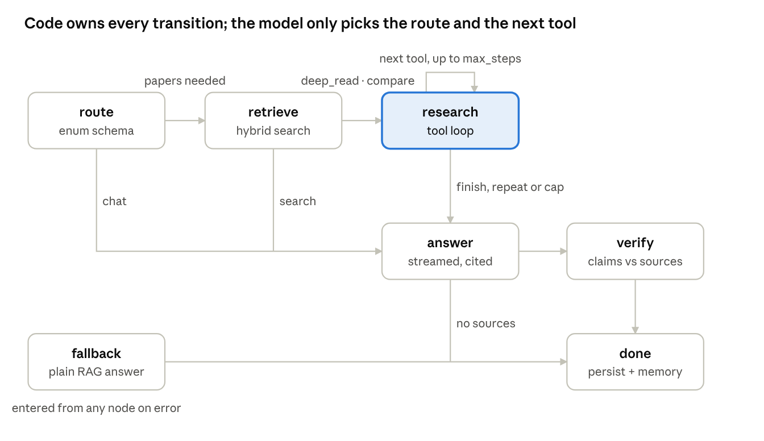
run state machine · 7 nodes
Only research loops, and it exits on finish, a repeated action or the step cap; any node that throws hands over to fallback, which still produces a grounded answer.

Tools (few, non-overlapping)
Tool | Input | Returns | Routes
search_papers | query, optional paper ids, k | Pointer hits: node id, breadcrumb, score (hybrid BM25 + vector, RRF-fused) | search, deep_read, compare
read_section | node id, max tokens | Full section text, expanded from the pointer, trimmed to budget | deep_read, compare
get_element | node id of a table or figure | Table as Markdown, or caption + image path (optional VLM description) | deep_read
save_note | claim, evidence, node id | Note id | deep_read, compare
finish | answer draft, cited node ids | Ends the loop | all
Each tool returns compact, token-efficient text with ids the model can cite. Tool descriptions state when not to use the tool.

Run state
RunState carries: run_id, session_id, route, step, max_steps, messages, scratchpad (tool calls and results this run), evidence (node ids + text actually shown to the model), notes, draft, errors, and status. It is checkpointed to the database after every node, so a crashed or cancelled run resumes from the last node and the UI can replay the trace.

SLM error recovery
Small models fail in predictable ways; each has a dedicated guard.
Failure | Guard
Malformed JSON or tool call | Schema-constrained decoding makes it rare; on validation error, retry once with the Pydantic error message appended (Instructor), then fall back
Valid JSON, wrong semantics (unknown node id, empty query) | Pydantic validators check ids against evidence and the DB; the error is returned to the model as a tool result, not raised
Looping (same tool + args twice) | Call signature hash in scratchpad; a repeat forces finish with what is in hand
Runaway loop | Hard max_steps (default 6) and a wall-clock budget per run
Ungrounded answer | verify node: one constrained call checks each claim against the evidence; unsupported claims are removed or marked, and at most one revise pass runs
Runtime errors (Ollama down, timeout, OOM) | Exponential backoff with jitter; on context overflow, shrink the retrieval slot and retry; surface a typed error event to the UI
Total failure of the agentic path | Deterministic fallback: plain hybrid search → top section → single answer call with citations
The fallback ladder means every request returns something grounded, even when the model misbehaves.

7. Local SLM optimization
The biggest wins, in order: constrain every structured output with a schema, set the context length explicitly and budget it, keep prompts short and route-specific, and pick the largest model that fits in VRAM at Q4_K_M.

Model and quantization
Quant (GGUF) | Relative size | Quality | Use when
Q8_0 | ~2× Q4 | Near lossless | Small models (≤3B) used for routing or verification
Q6_K / Q5_K_M | ~1.3–1.6× Q4 | Very close to Q8 | VRAM to spare; long-context synthesis
Q4_K_M | Baseline | Small, usually acceptable loss | Default for 7–9B generator
Q3_K_M and below | Smaller | Noticeable drops in instruction following and JSON reliability | Avoid for agent loops
- A larger model at Q4_K_M generally beats a smaller one at Q8; prefer stepping up a size class over adding bits.
- Pick a model with native tool-calling training and a context window of at least 32k, then run it at 8k–16k: quality and speed degrade toward the top of the window on small models.
- Quantize the KV cache (OLLAMA_FLASH_ATTENTION=1, OLLAMA_KV_CACHE_TYPE=q8_0) to roughly halve cache memory and afford a longer num_ctx.
- Benchmark candidates on your own 30–50 question eval set (section 10) before committing; leaderboards do not measure your prompts.

Prompt structure
- One small system prompt per route, not a universal mega-prompt. Sections in a fixed order with XML-style tags: <role>, <rules>, <notes>, <sources>, <history>, then the question last.
- Sources before the question, each prefixed with its id and breadcrumb ([n12] Methods > 3.2 Training), so the model can cite ids.
- Two or three short, diverse examples of the expected output for each constrained call; small models lean heavily on examples.
- Low temperature (0–0.2) for routing, tool choice, extraction and verification; 0.5–0.7 only for the final prose answer.
- Stop sequences and num_predict set on every call to cap runaway generation.
- Stable prefixes: keep system prompt and tool schemas byte-identical across turns so the runtime can reuse the KV cache for the prefix.

Constrained generation
- Define every structured step as a Pydantic model; pass Model.model_json_schema() to Ollama's format field, which constrains decoding to the schema (see Ollama structured outputs).
- Validate the result with model_validate_json; constrained decoding guarantees shape, not truth. Field validators enforce semantics (ids exist, enums, lengths).
- Wrap calls with Instructor (OpenAI-compatible mode against Ollama) for automatic re-ask with the validation error, max_retries=1 or 2.
- Keep schemas flat and small: short field names, enums instead of free strings, an explicit reasoning string field first when a decision needs a brief rationale.
- Stream only the final prose answer; structured steps run non-streaming.

Managing the context window
- Always set num_ctx explicitly; Ollama's default is small and over-length prompts are truncated rather than rejected, so a too-small window fails silently.
- Count tokens with the model's tokenizer and enforce the slot budgets from section 5 before every call.
- Retrieve sections, not chunks; if a section exceeds its slot, send the relevant subsection, or a map-reduce summary when the user asks about the whole paper.
- Use sub-contexts for comparisons: read each paper in its own short call that writes a note, then synthesize from the notes, never all papers at once.
- Keep the model resident (keep_alive) to avoid reload latency, and limit parallel requests to what VRAM can hold (OLLAMA_NUM_PARALLEL).

8. Frontend blueprint
The frontend is a thin React client driven entirely by one typed event stream from FastAPI; it never calls the model and holds no business logic, so it can be replaced (Chainlit, a CLI, an IDE plugin) without touching the backend.

Options considered
Option | Strength | Weakness | Verdict
Streamlit | Fastest to write | Rerun-on-every-interaction model fights streaming chat and multi-pane state | No
Chainlit | Chat, steps and source elements built in | Opinionated layout; harder to build a PDF side-by-side view | Prototype only (week 1)
FastAPI + React + Vite + Tailwind | Full control of layout, PDF viewer, trace view; clean API contract | More code | Production choice

API contract
Method | Path | Purpose
POST | /papers | Upload PDF; returns paper_id and job id
GET | /papers, /papers/{id} | Library list; paper metadata + section tree
GET | /papers/{id}/file | Raw PDF for the viewer
GET | /jobs/{id}/events | SSE: ingestion progress
POST | /sessions | New chat session
POST | /sessions/{id}/runs | Start a run with a user message; returns run_id
GET | /runs/{id}/events | SSE: the run's event stream (replayable from checkpoints)
POST | /runs/{id}/cancel | Cancel a run
GET / DELETE | /memory/facts | Inspect and delete semantic memory
SSE is chosen over WebSockets because the stream is one-way, reconnects automatically with Last-Event-ID, and passes through proxies unchanged. Cancellation is a plain POST.

Event schema
Every event is {run_id, seq, ts, type, data}. Types: route (chosen route), step (node started/finished), tool_call, tool_result (summary + node ids), source (paper, breadcrumb, page, score), token (answer delta), note, verify (claims kept or dropped), error, done (final answer + citations).

Layout
- Left: library. Papers with ingestion status, drag-and-drop upload, filters by tag/year.
- Centre: chat. Streams token events; inline citation chips [n12] link to the source pane.
- Right: tabs for Sources and Research log. Sources lists source events with breadcrumb, page and score, and opens the PDF at the page with pdf.js, highlighting the section. Research log renders route, step, tool_call, verify and error as a collapsible timeline, so users can see why an answer came out as it did.
State: TanStack Query for REST data, a small useRunStream(runId) hook that reduces SSE events into {answer, sources, log, status}. Tailwind for styling, no component framework required.

9. Code skeleton walkthrough
The accompanying paper-assistant.zip (~1,300 lines) implements the ingestion pipeline, Proxy-Pointer retrieval, the state machine, memory and the SSE API; its 8 end-to-end tests run against a scripted fake model, so the loop is verified without Ollama. The API and HTTP client were syntax-checked but not run here, because those packages could not be installed in the build environment.

Ingestion core: skeleton tree to pointers (app/ingest/tree.py, pipeline.py)
root = build_tree(markdown, paper_id, meta.title) # headings -> hierarchy, tables/figures -> child nodes
size_nodes(root) # split >1,500-token sections, fold tiny leaves upward
nodes = list(walk(root))
embeddable = [n for n in nodes if n.kind != "root" and n.embeddable]
ptexts = [pointer_text(n) for n in embeddable] # breadcrumb + lead sentences: the proxy
vectors = await llm.embed(ptexts)
with store.tx() as c: # one transaction: paper, nodes, pointers, FTS, vectors
...insert papers / nodes (whole text) / pointers (embedding BLOB) / pointers_fts...
Only pointers are embedded; nodes hold whole sections. Metadata extraction is a constrained call into PaperMetadata, whose validators drop malformed DOIs and arXiv ids.

Constrained generation (app/llm.py)
async def structured(self, messages, schema, *, model=None, temperature=0.0, max_tokens=512):
msgs = list(messages)
for attempt in range(settings.schema_retries + 1):
data = await self._post("/api/chat", {
"model": model or settings.gen_model, "messages": msgs, "stream": False,
"format": schema.model_json_schema(), # grammar-constrained decoding
"options": {"temperature": temperature, "num_predict": max_tokens,
"num_ctx": settings.budgets.num_ctx}}) # always explicit
raw = data["message"]["content"]
try:
return schema.model_validate_json(raw) # semantic validation
except ValidationError as e:
if attempt == settings.schema_retries:
raise LLMError(...) from e
msgs += [{"role": "assistant", "content": raw},
{"role": "user", "content": f"That JSON failed validation:\n{e}\nReturn corrected JSON only."}]

Agent state management (app/agent/graph.py)
async def _drive(self, state: RunState) -> None:
while state.node != "done" and state.status == "running":
current = state.node
self.emit(state, "step", {"node": current, "phase": "start"})
try:
state.node = await self.nodes[current](state) # each node returns the next node name
except Exception as e: # any failure -> deterministic fallback, once
state.errors.append(f"{current}: {e}")
self.emit(state, "error", {"node": current, "message": str(e)[:300]})
if current == "fallback":
state.status = "failed"; break
state.node = "fallback"
self.checkpoint(state) # resumable from state.node
Inside research, each step is one ToolCall (a five-value enum of tools). Code hashes each call's signature and finishes on a repeat, enforces max_steps, and turns tool failures into short results the model can act on. run() executes _drive as a task and yields events from a per-run queue, so answer tokens stream live and a client disconnect cancels the run.

What the tests prove (tests/test_core.py)
Test | Behaviour verified
test_skeleton_tree_breadcrumbs_and_elements | Breadcrumbs, table and figure nodes, noise sections excluded from the index
test_oversized_section_is_split | Large sections split into breadcrumbed parts
test_ingest_and_hybrid_search_finds_the_right_section | Atomic ingest; BM25 + vector RRF ranks the correct section first; DOI validator works
test_context_budget_drops_whole_sections_first | Assembler drops low-ranked sections rather than truncating
test_full_deep_read_run_streams_events_and_cites | Route → retrieve → tool loop → note → streamed answer → verify; citations; ordered events; checkpoint
test_loop_detection_stops_repeated_tool_calls | A repeated action ends the loop
test_schema_failure_falls_back_to_grounded_answer | A router schema failure still yields a grounded answer via fallback
test_chat_route_skips_retrieval | Chat route makes no retrieval, tool or verify calls

10. Roadmap, evaluation and risks
Ship retrieval quality first and autonomy last: each phase is gated by the eval set, so agentic features are added only when they beat the simpler path.
- Phase 1 — Grounded Q&A. Ingestion, skeleton tree, hybrid search, single answer call with citations, SSE chat UI. Gate: retrieval hit@5 on the eval set.
- Phase 2 — Router and research loop. Constrained router, tool loop with step cap, verify node, checkpointing, research log pane. Gate: answer faithfulness beats Phase 1 without higher latency than you can accept.
- Phase 3 — Memory. Rolling summaries, research notebook, post-run fact extraction, memory inspector UI. Gate: multi-session tasks succeed without re-explaining context.
- Phase 4 — Multi-paper and multimodal. Comparison route with per-paper sub-contexts, table/figure tools, optional local VLM for figures.

Evaluation
- Eval set: 30–50 questions over 10–20 of your own papers, each with gold node ids and a reference answer; include table and figure questions and cross-paper comparisons.
- Retrieval metrics: hit@k and MRR on gold node ids, computed without the generator. Run on every change to parsing, chunk sizing or embeddings.
- Answer metrics: citation precision (cited nodes actually support the claim), faithfulness via the verify node or a stronger judge model run offline, and refusal correctness on unanswerable questions.
- Ops metrics: time to first token, total latency per route, steps per run, schema-retry rate, fallback rate. A rising retry or fallback rate is the earliest sign a model or prompt change hurt.

Risks
Risk | Mitigation
PDF parsing errors on equations and two-column layouts | Parser fallback chain; per-paper warnings; let users view the parsed tree beside the PDF
Model swap changes tool-calling behaviour | Pin model tags; re-run the eval set before upgrading
Embedding model change invalidates vectors | Store model name and dimension per vector; background re-embed job
Memory accumulates wrong facts | Provenance, validity windows, deletion UI, post-run extraction with dedupe
VRAM pressure from long contexts | KV cache quantization, fixed num_ctx, one resident model

Sources
- Building effective agents — Anthropic
- Effective context engineering for AI agents — Anthropic
- 6 agentic knowledge base patterns emerging in the wild — The New Stack
- Proxy-Pointer RAG: Structure Meets Scale — Towards Data Science
- Proxy-Pointer RAG: Multimodal Answers Without Multimodal Embeddings — Towards Data Science
- The Case Against External Vector DBs for Agent Memory — Hindsight
- The Database Layer Your Agent Stack Is Missing — Towards AI
- Structured outputs — Ollama docs

